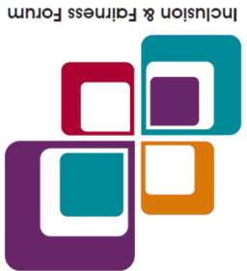

**Inclusion & Fairness Forum**



**The Inclusion & Fairness Forum** (I&FF) Leadership Team supports the

Team Doncaster Strategic Partnership to increase understanding of the challenges related to inclusion and fairness of local people from all walks of life.

The Doncaster Inclusion & Fairness Forum is an independent advisory group that explores and identifies ways to make Doncaster a fairer place to live and work.

Our aim is to:

* Increase the understanding of the challenges related to inclusion and fairness facing those who live, work or visit Doncaster.
* Research and consult with and examine people’s views on key priorities and the impact of making significant changes to services.
* Develop appropriate working arrangements and community pathways to enable Doncaster’s diverse voices to be heard.
* Champion diversity and embed our new Equality, Diversity & Inclusion Statement with a wide range of partner organisations across Doncaster.

**Have Your Say**

The Forum holds interactive Zoom meetings every second and fourth Tuesday of the month 6:30pm – 7:30pm and we would love to hear what you have to say. The **Meeting ID is: 897 411 0843** and the **Passcode is: 1421**. You can also use the Zoom link:

[**https://us02web.zoom.us/j/8974110843?pwd=WmFkaklKdVhPY2pveWJuQTc0TElKdz09**](https://us02web.zoom.us/j/8974110843?pwd=WmFkaklKdVhPY2pveWJuQTc0TElKdz09)

**If you prefer you can also have your say by sending us an email to:** [equalities@doncaster.gov.uk](mailto:equalities@doncaster.gov.uk)

To find out more information about the Inclusion & Fairness Forum visit our website: <https://www.teamdoncaster.org.uk/inclusion-fairness-forum>

## We look forward to hearing from you

## Rev. Adedolapo (Dolly) Agoro & ****Akeela Mohammed DL****

## ****Inclusion & Fairness Forum Leadership Team****